**VISHWAKARMA INSTITUTE OF TECHNOLOGY**

COMPUTER ENGINEERING

**Name: Ayush Surendra Billade**

**Division: CSA**

**Roll Number: 38**

**Subject: Operating System (OS) LAB**

**Shell Script**

**Write a shell script for**

**1.For Calculator using command line arguments**

#!/bin/bash

if [ $# -ne 3 ]

then

echo "Usage: $0 num1 operator num2"

exit 1

fi

num1=$1

operator=$2

num2=$3

case $operator in

+)

result=$((num1 + num2))

;;

-)

result=$((num1 - num2))

;;

\*)

result=$((num1 * num2))

;;

/)

result=$((num1 / num2))

;;

*)

echo "Invalid operator: $operator"

exit 1

;;

esac

echo "$num1 $operator $num2 = $result"

**Output:**

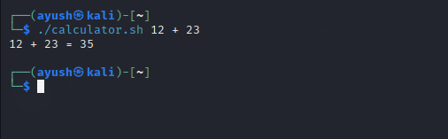

1. **To accept the strings & to reverse the string.**

Code: #!/bin/bash

echo "Enter a string: "

read str

len=${#str}

rev=""

for (( i=$len-1; i>=0; i-- ))

do

rev="$rev${str:$i:1}"

done

echo "The reversed string is: $rev"

**Output:**

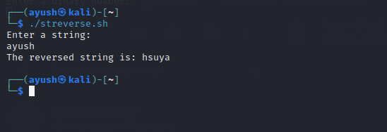

1. **To execute linux commands using case statement.**

Code:

#!/bin/bash

echo "For date enter 1"

echo "For current user 2"

echo "For no of files current directry 3"

echo "For current working directry 4"

read n

case $n in

1)

echo `date`

;;

2)

u="$USER"

echo "User name $u"

;;

3)

echo " $(ls | wc -l)"

echo " $(ls)"

;;

4)

echo " $(pwd)"

;;

*)

echo "Invalid operator: $operator"

 exit 1

 ;;

esac

**Output:**

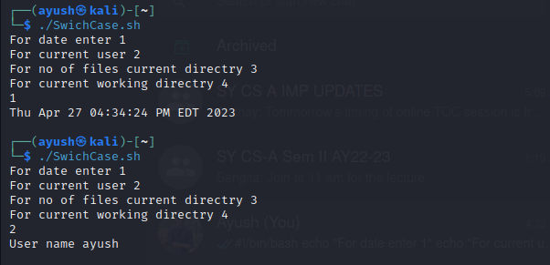

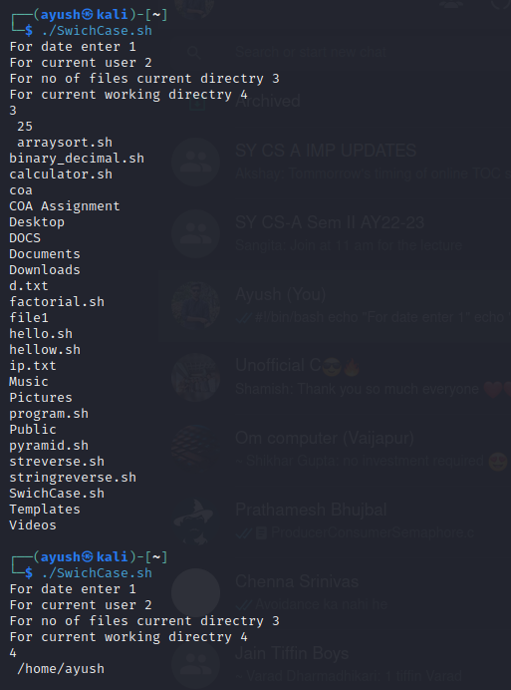

1. **To print the pyramid of \***

Code:

#!/bin/bash

echo "Enter the number of rows for the pyramid: "

read rows

for (( i=1; i<=rows; i++ ))

do

for (( j=1; j<=rows-i; j++ ))

do

echo -n " "

done

for (( k=1; k<=2*i-1; k++ ))

do

echo -n "*"

done

    echo

done

**Output:**

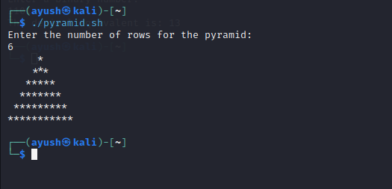

**5.To write a function for factorial of a number**

Code:

#!/bin/bash

factorial() {

if [ $1 -eq 0 ]

then

echo 1

else

prev=$(factorial $(( $1 - 1 )))

echo $(( $1 * $prev ))

fi

}

echo "Enter a number: "

read num

fact=$(factorial $num)

echo "The factorial of $num is $fact"

**Output:**

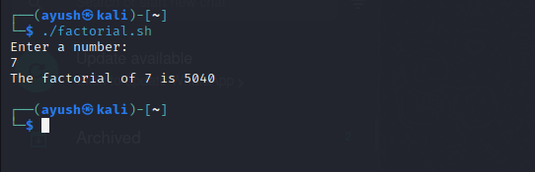

**6. To sort the given elements using any sorting method.**

#!/bin/bash

echo "Enter number of elements"

read n

echo "enter Numbers in array:"

for (( i = 0; i < $n; i++ ))

do

read nos[$i]

done

for (( i = 0; i < $n ; i++ ))

do

for (( j = $i; j < $n; j++ ))

do

if [ ${nos[$i]} -gt ${nos[$j]} ];

then

t=${nos[$i]}

nos[$i]=${nos[$j]}

nos[$j]=$t

fi

done

done

echo -e "\nSorted Numbers "

for (( i=0; i < $n; i++ ))

do

echo ${nos[$i]}

done

**Output:**

